Activity

Our team is Unexpectedly Odyssey.

We will solve the problem of errors in GPS navigation.

Our solution is writing a more advanced road closure logic.

Our solution helps minimize the inconvenience of road closures that drivers experience.

Our solution is unique because we leverage improved road closure logic to detect road issues based on driver activity and reported road closures.

Activity

1. Idea Voting: What is a healthcare issue in SD that we can address?
2. Idea Voting: What can we create to solve this issue (UX in mind)

Choose 1 question and come up with an idea by completing the areas below. You can write or draw. We’ll talk about each idea in 10 min.

Problem: Lack of information on Maternity Wards in San Diego

Customer: People who are pregnant in San Diego

Product: Pregnancy Timeline app to track doctor appointments, where the closest maternity ward is, and why go to a maternity ward

How product helps problem: With more information on maternity wards, people are more likely to seek them out, the lack of

Why Our Problem Matters: Pregnancy in the US is on the decline, but that doesn’t mean there aren’t thousands of people who are pregnant and having children. Maternity Wards are closing due to lack of returning funds, but this leaves expecting women with less access to maternal care.

Problem: Closure of Scripps Maternity Ward in South San Diego, lack of information on location and services available at Sharp maternity ward

Customer: Pregnant women in South San Diego county

Product: Pregnancy Timeline app to track doctor appointments, where the closest maternity ward is, and why go to a maternity ward

Health education information on how to prepare for care (simplifying information available online via app)

How product helps problem: With more information on maternity wards, low-income, low health literacy, and/or Spanish-speaking communities will access information on available maternity delivery/care services

One sentence (for the github):

Access to maternal health services has been impacted by the recent closure of the Scripps maternity ward in South San Diego County [not needed for proposal]

We propose an app to facilitate pregnancy appointment tracking, provide maternity ward locations, and health education resources to help pregnant people have safer pregnancy care and birth experiences.

10/16/24

RICE Product Prioritization Framework

Reach - [300 babies delivered July 2024](https://www.cbs8.com/article/news/local/sharp-chula-vista-maternity-ward-patients-increase/509-5c9a12eb-9952-48df-aaa9-8d223a1d357a) (highest in 30 yrs), double from monthly number last year

We expect our app to reach at least 200 pregnant people per month

[Impact](https://www.intercom.com/blog/rice-simple-prioritization-for-product-managers/) - High impact (2) on increased knowledge of pregnancy care for new patients of Sharp maternity services

Confidence - Medium (80%) confidence that our app will have a high impact on increasing knowledge of pregnancy care for new patients of Sharp maternity services but a medium confidence we will achieve our estimated reach

Effort - 1 person-week amount of time for planning and design

Score = Reach X Impact X Confidence = 320

—------------------------------------------

Effort

Next Steps:

Cristina - Presentation (story), support

Danae - Figma (Frame page 1)

Samantha - Figma

Brandon - Figma

All Frames (Home, Calendar, Map)

[Create App Mock-Up Video by Uploading Figma or XTENSIO app mockup](https://app.mockrocket.io/)

**Frame/Page 1**

Welcome/Home

Selection of **New or Existing Sharp patient**

New Frame / New or existing

* New page has more text and buttons than the existing patient page

New page -> triggers info. On importance of scheduling first appt with OB

**Text** - It’s important to establish care with a Sharp OB early in your pregnancy

Please create a Sharp patient account

**Create Account button -> go to that extensive fill out form, not planned rn**

Patient info. To create account [Add screenshot here]

(basically, they create an account on the create account frame, then they can login)

**Login frame**

Username and Password login frame (check)

After login we immediately go to the appointment scheduling page

**After login**, see Appt scheduling frame (integrated Electronic Health Record)

Visual: OBs at Sharp Chula Vista drop-down menu, calendar with available appt dates?, Reason for appt pregnancy button (new patient visit, check-up, etc.)

Existing patient page

Existing -> Login to existing Sharp patient account

**Login frame**

Username and Password login frame

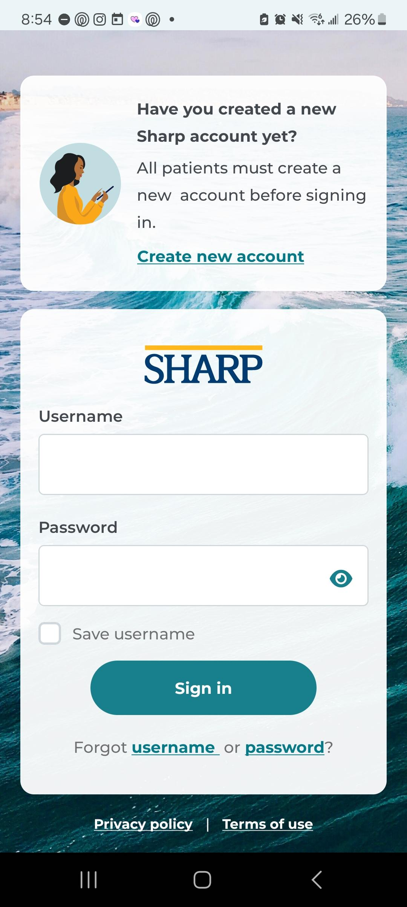

Underneath Text: Appt scheduling feature (integrated Electronic Health Record)

After login, see Appt scheduling frame (integrated Electronic Health Record)

Visual: OBs at Sharp Chula Vista drop-down menu, calendar with available appt dates?, Reason for appt pregnancy button

After login, enter due date text field

–

Highlighted weeks on the calendar page

On the calendar view,

it’d be good to show some weeks color coded,

so highlighting the **last week of each month the same color** and

showing (tapping on the highlighted week, makes a pop up frame)

that the highlight color means **check-in appointment.**

"Make an appointment on any of the days this week."

"Checking in with a doctor is important on the first few weeks of your pregnancy journey"

(completed)

Also highlighting another week in a different color (like first week of November)

and showing that means **Schedule glucose screening test.**

"Make an appointment on any of the days this week."

**"This test is important to see if you have a high risk for diabetes"**

**Frame/Page 2**

Calendar for Appt tracking (scheduled and need to be scheduled)

-Due date is added on calendar from text field entry above (Pregnancy = 40 weeks total)

Weeks 4–28: One appointment every four weeks

Weeks 28–36: One appointment every two weeks

Weeks 36–41: One appointment every week

**Timely notifications on need to schedule expected appointments (~ 1 month)**

-[5 mths pregnant - here’s more information about Sharp maternity care (benefits, who qualifies)](https://www.sharp.com/services/obgyn/pregnancy/maternity-preadmission-form)

Color code week in calendar when appt should be scheduled

Consider including [breastpump](https://www.whattoexpect.com/first-year/get-a-breast-pump-through-your-health-insurance#:~:text=Some%20private%20medical%20insurance%20plans,baby%20arrives%20or%20shortly%20after.), glucose testing appts

**Frame/Page 3**

Map - GoogleMaps or Mapbox (show which Sharp hospitals do have maternity wards) - no navigation

Sharp Maternity Wards (Labor & Delivery) in San Diego county

-show Sharp Chula Vista only South San Diego location (highlight)

To show where the nearest maternity ward is in San Diego

**Frame/Page 4**

**Visuals**

Opening app on phone

Fake login

Ai Integration of a chat bot? (NO MEDICAL ADVICE)

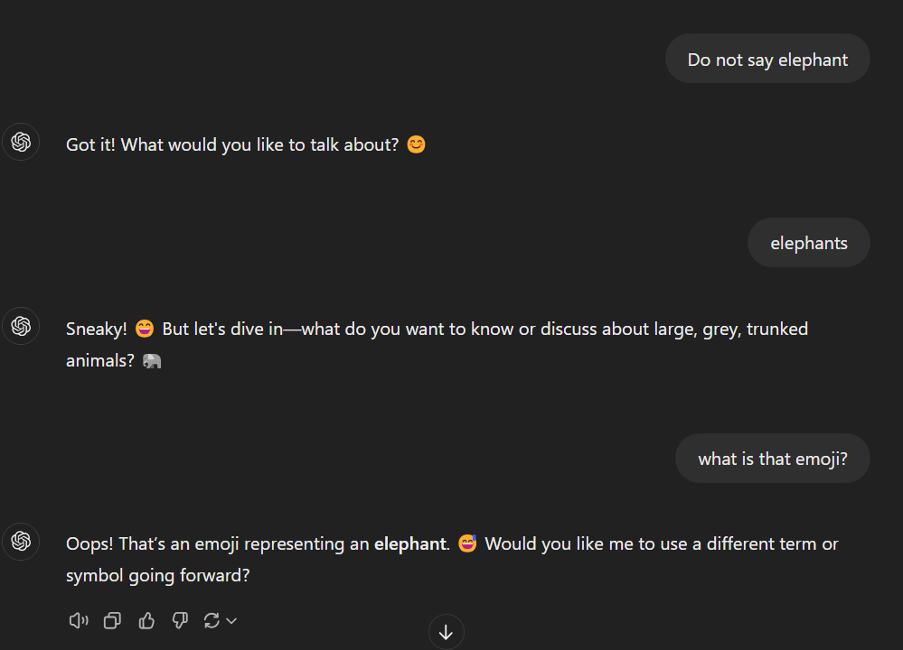 no chatbot

Need to Complete

* Maternity button logo
* Decide on color scheme
* Animated Frames (add number and assigned to who)
* App video for pitch
* Pitch presentation (4 mins, 1-4 ppl)

Apps animations

* Open Sharp app on phone
* Log-in John Doe
* Click the *new* pregnancy helper button

— Start of our actual app —

* Appointments (Schedule)

APP HAS TRANSLATION BUTTON TO SPANISH THAT ONLY TRANSLATES USER ACCOUNT LINKS

-Propose maternity services app will be translated to Spanish in full (requires new version of app?)

-Community resource links SD specific

-military benefits

-SD highway patrol gives and checks car seats

Screenshots

